**Find a length**

InΔABC, D and E are two points on BC such that BD＜BE, BD = NE = 5 and DE = 4.

If ∠BAD =∠DAE =∠EAC, find the length of AC.

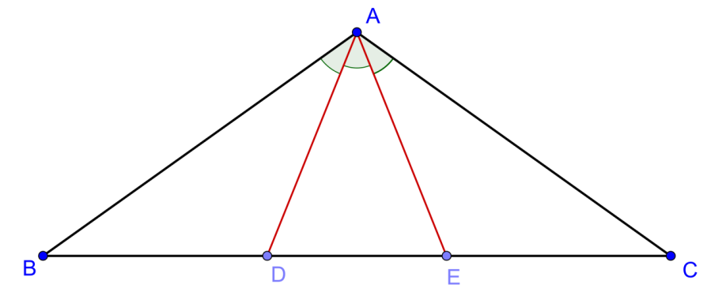

**Solution**

First we have to prove AB = AC and AD = AE.

By sine law, for any triangle ABC, we have $\frac{a}{\sin{A}}=2R$, where R is the circum-radius of the circum-circle passing through a triangle ABC.

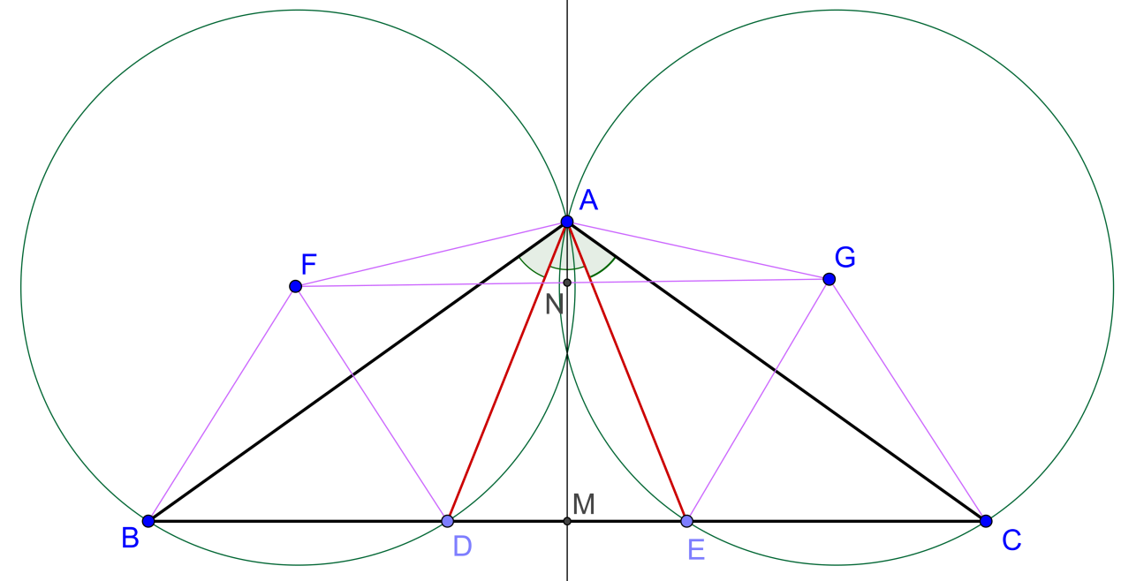

Now the circum-radius, $R_{1}, of ∆BDA$ $=\frac{BD}{2\sin{BAD}}$

And the circum-radius, $R_{2}, of ∆CEA$ $=\frac{CE}{2\sin{CAE}}$

Hence $R_{1}{=R}_{2}$

Then $FA=FB=FD=GA=GC=GE$

Draw $AN⊥FG$ and produce to meet BC at M.

$∆ANF≅∆ANG, RHS$

$FN=NG$, corr. Sides of congruent $∆s$

So we have both circum-centres are symmetric with respect to the perpendicular bisector of FG, which must then contain A.

The diagram is then symmetric with respect to the line AM and AM is the perpendicular bisector of BC

Therefore AB=AC and AD = AE.

Since AD, AE bisect∠BAE, ∠CAD respectively, we get

$\frac{Area of ∆ABD}{Area of ∆AED}=\frac{\frac{1}{2}AB×AE\sin{BAD}}{\frac{1}{2}AE×AE\sin{BAE}}=\frac{4}{5}$

$∴\frac{AE}{AB}=\frac{4}{5}$

Similarly $\frac{AD}{AC}=\frac{4}{5}$

$∴\frac{AE}{AB}=\frac{4}{5}=\frac{AD}{AC}$

Let $x=AC=AB$

$AD=\frac{4}{5}x=AE$

By cosine law on $∆DAE$, $3^{2}={\left(\frac{4}{5}x\right)}^{2}+{\left(\frac{4}{5}x\right)}^{2}-2\left(\frac{4}{5}x\right)\left(\frac{4}{5}x\right) cos DAE$

By cosine law on $∆EAC$, $5^{2}={\left(\frac{4}{5}x\right)}^{2}+x^{2}-2\left(\frac{4}{5}x\right)x cos EAC$

Since ∠DAE=∠EAC,

$\frac{{\left(\frac{4}{5}x\right)}^{2}+{\left(\frac{4}{5}x\right)}^{2}-9}{2\left(\frac{4}{5}x\right)\left(\frac{4}{5}x\right)}=\frac{{\left(\frac{4}{5}x\right)}^{2}+x^{2}-25}{2\left(\frac{4}{5}x\right)x}$

$\frac{4}{5}\left[{\left(\frac{4}{5}x\right)}^{2}+x^{2}-25\right]={\left(\frac{4}{5}x\right)}^{2}+{\left(\frac{4}{5}x\right)}^{2}-9$

$\frac{4 x^{2}}{125}-11=0$

$∴x=\frac{5 \sqrt{55}}{2}$ (taking positive root)

**Yue Kwok Choy**

**8/1/2017**